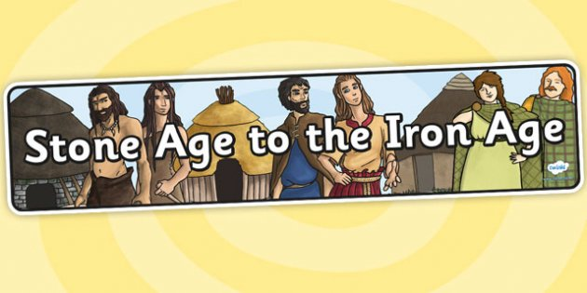

Dear Parents,
I hope that you enjoyed a relaxing half term and that the children are ready for the busy time ahead as we prepare for Christmas!
This letter is to give you some further information about the topics that Year 3 will be covering over the course of this half term.
English
In English we will be looking at the genre of information reports and to link in with our Stone Age work writing our own reports about a particular area from the topic which we are most interested in. We will study closely the features of an information report and evaluate how effective an existing selection of reports is.
Maths
The maths areas which will be covered this half-term are number and place value, mental multiplication and division, along with time, money, fractions and 3D shapes. Year 3 will also do problem solving investigations on a regular basis and a weekly times table challenge. Please can you use the home learning cards distributed to practice times tables with your child and ensure these are sent back into school regularly so the children can be tested on their target times table of choice.
History
Year 3 will be travelling back in time this half-term through our Stone Age topic where we will be looking at Stone Age houses, diet, making our own timelines and comparing the main differences between life today and the Stone Age.
PE
Year 3will continue to do invasion games for PE on Tuesday mornings and they will also have sessions on Wednesday afternoons with Mrs Debney. Children should have their full PE kit with them all week in school.
Art/DT
Pupils will participate in a variety of Stone Age themed activities including creating their own cave paintings and weapons/clay work for DT.

ICT
In ICT we will be learning about how to use the internet to research information for our Stone Age topic.
Science
Our science this half-term will be light and shadow which will include making our own dark-boxes, looking at how shadows are formed and producing our own shadow puppet show.
Homework
Homework for topic will be due in fortnightly and a creative learning grid has been sent out which your child will choose each task from. In addition spelling homework will be set each Thursdayto be tested the following Thursday. It is also encouraged that pupils practise their times tables at home as well as at school so they know them off by heart and home learning cards will be distributed. Online maths homework will also be allocated later this half-term in the form of games or a quiz to help further reinforce the week’s learning objectives.
As always if you have any questions or concerns regarding your child or any queries about the topics, please do not hesitate to get in touch with us.
Yours sincerely,

Miss Meakin

