 | BEN RHYDDING PRIMARY SCHOOL  Bolling Road  Ben Rhydding  Ilkley LS29 8QH  T: +44 (0) 1943 431133  F: +44 (0) 1943 433479  E: office@benrhydding.bradford.sch.uk  www.benrhydding.ngfl.ac.uk  Executive Headteacher: Mrs C Lee
4th December 2015
SCHOOL NEWS
Dear Parent/Carer,

I would like to say an enormous thank you to the huge number of people who supported the Christmas Fayre on Sunday and of course to the members of the PTA, teachers and children who helped to make it such a success. The total raised is certainly something to be proud of. And so with December now upon us, we begin the festive madness that is school business in the run up to Christmas - with lots of learning in between of course!

Festive Hat Competition and Christmas Jumper Day
Christmas Lunch on Wednesday 16th December – As you know it is our tradition to make the lunch a bit special by holding a Festive Hat Competition. We are therefore asking all the children to bring a hat in to wear on Christmas Lunch Day and then we will have prizes in every class for the most inventive and original creations. Children may also wear a Christmas jumper too if they wish.

I would like to draw your attention to some changes that have been made to staffing from January which is different to that originally outlined. Miss Besharati and Miss Foster will continue to share responsibility for the Year 5 class. To replace Miss Meakin, Year 3 will have a newly appointed teacher to the school, Miss Kelly, who joins us having taught previously at Ireland Wood Primary School in Leeds.

Thank you to the parents who have been able to join us for the class assemblies from Year 5 and Year 6. It is always great to see the children share their learning whilst honing their public speaking skills.

I look forward to seeing you in school over the coming weeks at the variety of Christmas productions and thank you for your support in the last few weeks. You have helped me to feel very much part of the Ben Rhydding community so quickly; it is much appreciated.
As ever, if you have any queries or concerns, please do not hesitate to contact me in school.
Kind regards

Claire Lee
LEARNING HEROES FOR THIS WEEK

Year Group | Reason
Reception – James Hammond | For working well in a group and making everyone feel included.
Year 1 - Sophie White | For being resilient, hardworking and always trying her best.
Year 2 - Rebecca Mann | For being a good role model, honest, kind and hard working
Year 3 - Louis Tuxworth | For being an exceptional role model.
Year 4 - Jackson Bleazard | For having the courage to be honest and always being a polite member of the class.
Year 5 - Stanley Morton | For being more focused on learning and being adaptable when working in a group.
Year 6 - Felix Lock | For being a great listener which creates an effective learner – well done. For being skilled at being patient, never shouting out and showing respect.

Winners of the ‘E Safety’ Poster Competition
Lottie Addenbrook, Year 6 and Stanley Morton, Year 5
The Runners Up were: Isabelle Starr & Clare Soundy, Year 6 and Olivia Walsh and Tizzy Burrows, Year 5

Thank you from the PTA
We would like to say a big thank you to everyone who helped us pull together the Christmas fayre. In particular Julie Devonald for negotiating fabulous raffle prizes, Melissa Morton for creating the brochure and finding great sponsors, Sarah Winterbottom for printing the brochure, Jo Pattinson for making a fabulous 'guess the weight' of the cake, Katie Poulson for organising the Secrets Room and all the other class reps for pulling stalls together to add to the fun on the day, Emma Benson for co-ordinating the store holders in the shopping room, Simon and Fiona Throp and Karen Allister for keeping us supplied with mulled wine and mince pies, Becky Picken for getting Father Christmas to visit us and get us into the Christmas spirit, Jane Elms for running the face painting stall, Haley Cooper for running the craft room and of course all the fabulous parents and pupils who volunteered to man a stall on the day. A thank you goes also to Jeff Green (PTA treasurer) for his coin counting and number crunching. We would also like to thank Mrs Lorimer, Mrs Idle and the school choir who created a great festive atmosphere, and the teachers and staff who created amazing displays in the hall and supported us throughout the weekend setting up and dismantling the fayre......and finally of course to all of you who came along and supported the event! We have raised over £2,000 for the PTA which will be used to support the school. Thank you Kristy Walton and Fiona Pitt

There are still a few PTA Calendars left to purchase in the school office.

Diary Dates:
- Key Stage 1 Nativity – Wednesday 9th December at 6pm (children to arrive at 5.30pm)
- Key Stage 1 Nativity – Friday 11th December at 9.15am
- Tuesday 15th December - School Carol Concert with Ilkley Choral Society at St John’s Church at 7pm.
- Saturday 23rd January 2016 - Provisional date for Ben Rhydding Primary School Cross Country. Did out your thermals!
School Choir at:
- Emmandjay Court 4.12.15(within school hours), The Wheatley 6.12.15 4.30-5pm, Glen Rosa 10 12.15 3.30 – 4pm, St John’s 15.12.15 7-8pm, 17.12.15 The Troutbeck (within school hours).

Poppy Appeal
The amount raised for this year’s Royal British Legion Poppy Appeal was £331.67. Thank you

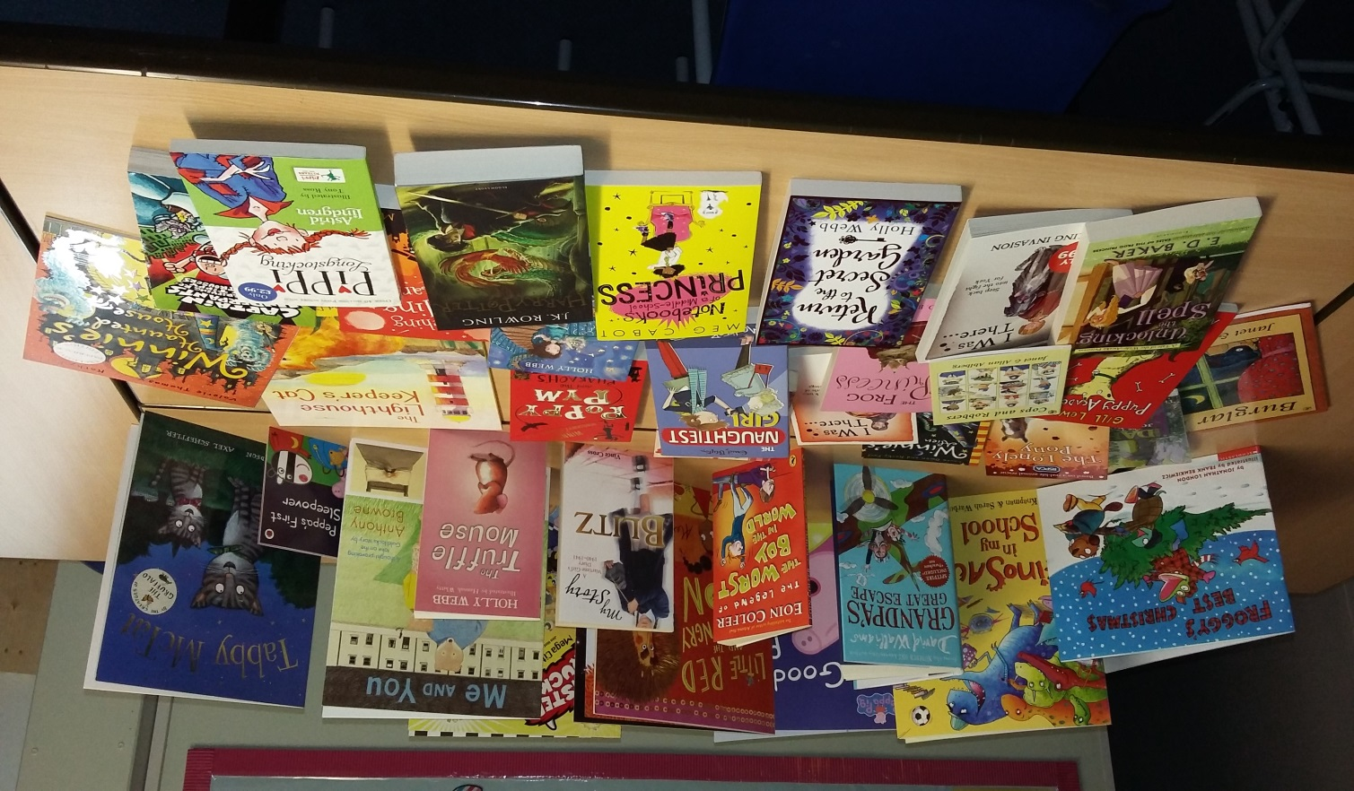

Another successful book fair!
Thank you so much to everyone
who came and supported it.
Your contributions raised a fantastic £652.00.
This has allowed us to buy more
books for our school.
Next book fair June 2016.

